**Nome:** Hállan da Silva Costa 2° Semestre ADS

**UNIT 3.1 WORK**

**ACTIVITY A**

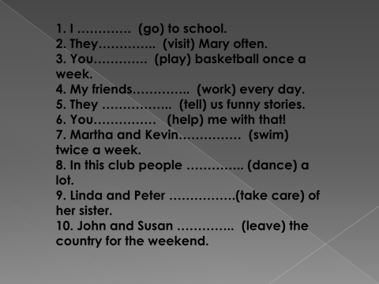

|  |
| --- |
| 1. **go** |
| 1. **visit** |
| 1. **play** |
| 1. **work** |
| 1. **tell** |
| 1. **help** |
| 1. **swim** |
| 1. **dance** |
| 1. **take care** |
| 1. **leave** |

**ACTIVITY B**

WHERE DO YOU WORK? I don’t work.

WHAT DO YOU DO? I'm a web developer FullStack.

WHAT COMPANY DO YOU WORK FOR? I don't work in a company.

DO YOU LIVE IN ARAÇATUBA? Yes, of Course.